

Tech Saksham

Capstone Project Report

ARTIFICIAL INTELLIGENCE AND MACHINE LEARNING FUNDAMENTALS

**“Heart Disease Prediction”**

**“J.J. COLLEGE OF ENGINEERING AND TECHNOLOGY -TRICHY”**

|  |  |
| --- | --- |
| **NM ID** | **NAME** |
| aut22lme03 | GOKUL NIKETHAN.U |

Master Trainer: Trainer Name:

**RAMAR BOSE**

**ABSTRACT**

Heart disease remains a significant public health concern globally, with early detection and intervention playing pivotal roles in mitigating its impact. Machine learning techniques, particularly logistic regression, have gained traction in predicting the likelihood of heart disease development based on various risk factors. This study aims to develop and evaluate a logistic regression model for heart disease prediction using a dataset comprising demographic, clinical, and lifestyle variables

**INDEX**

|  |  |
| --- | --- |
| **Sl. No.** | **Table of Contents** |
|  | Introduction |
|  | Project Outcome |
|  | Conclusion |
|  | Future Scope |
|  | References |
|  | Code |



**INTRODUCTION :**

# 1.1 Problem Statement

# 1.2 Proposed Solution

# 1.3 Feature

# 1.4 Advantages

# 1.5 Scope

# 1.6 Future Work

# 2.1 Problem Statement :

* The problem statement in a ‘**Heart Disease Prediction’** project typically revolves around creating an algorithm.
* The goal to enhance user experience by providing personalized and recommendations that cater to individual tastes and preferences, ultimately increasing user engagement and satisfaction with the platform.

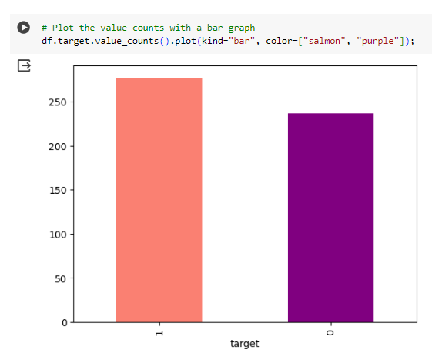

**PROJECT OUTCOME**

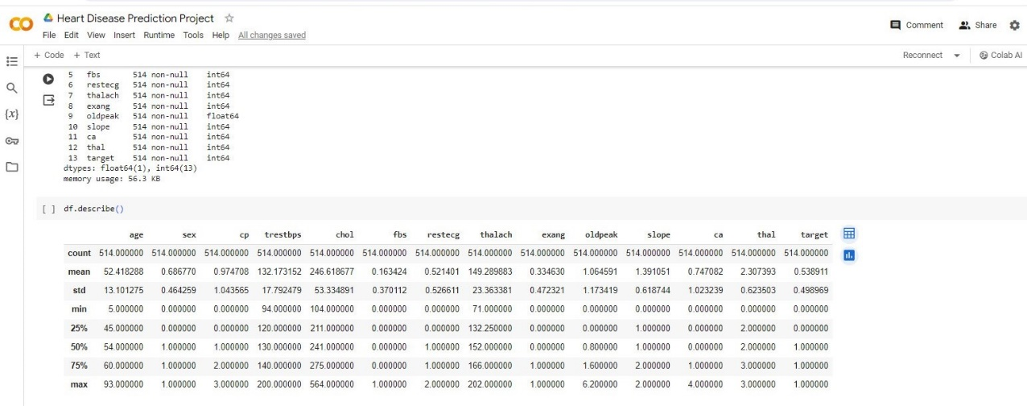

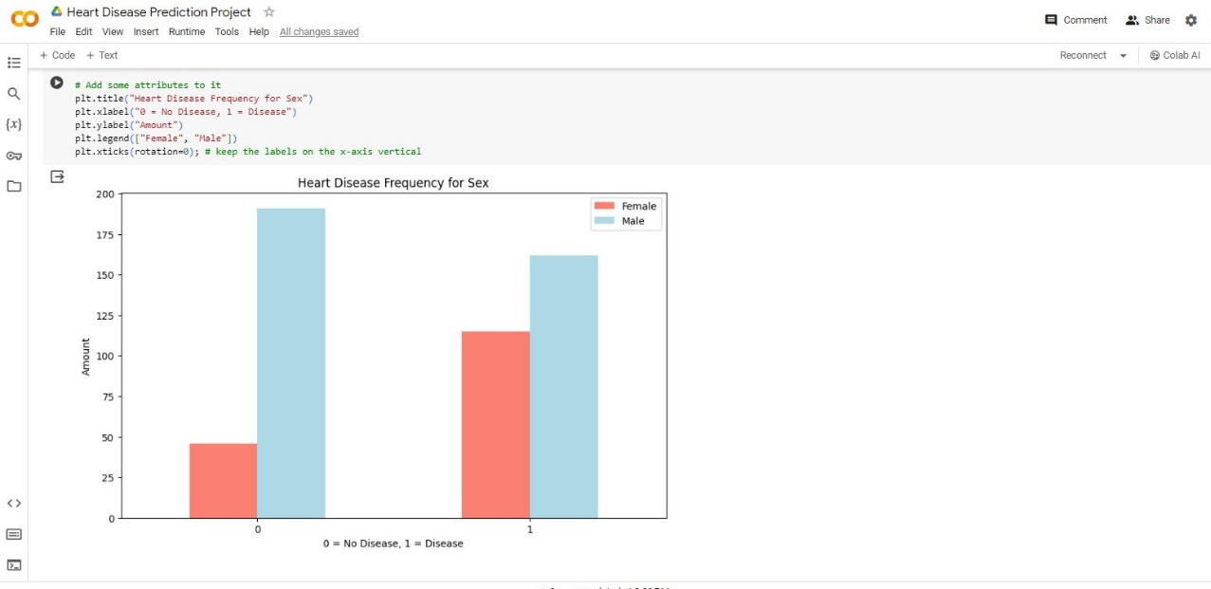

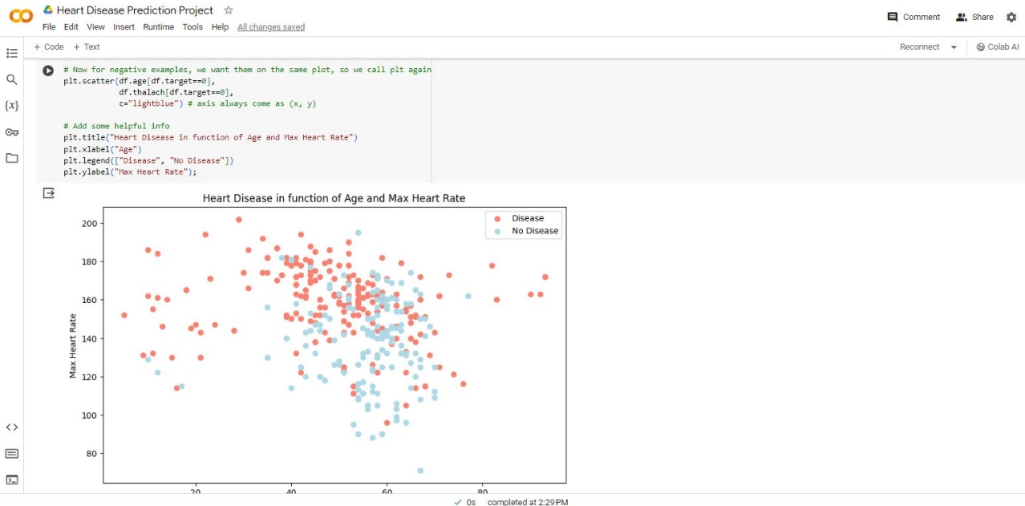

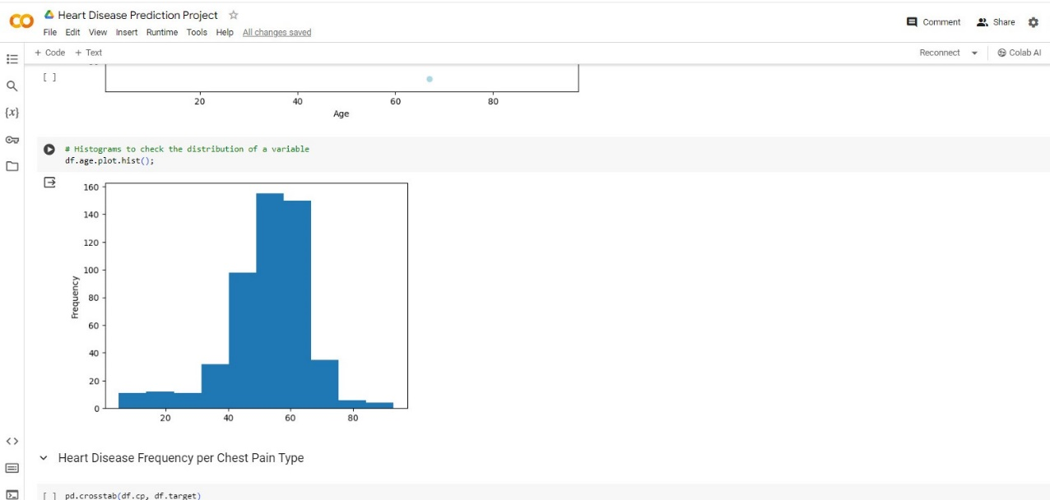

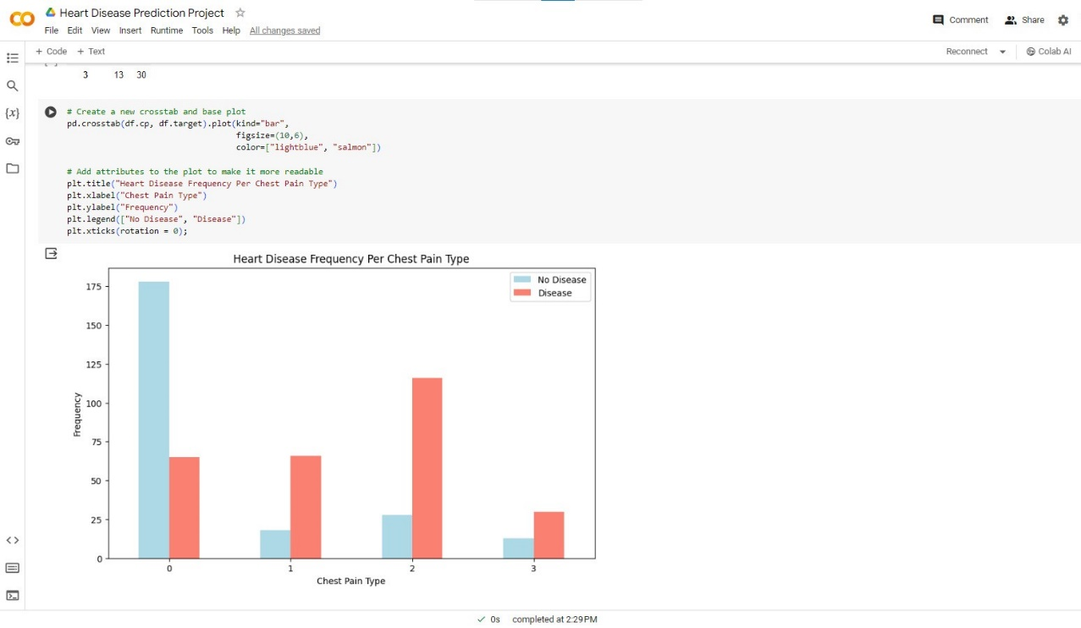

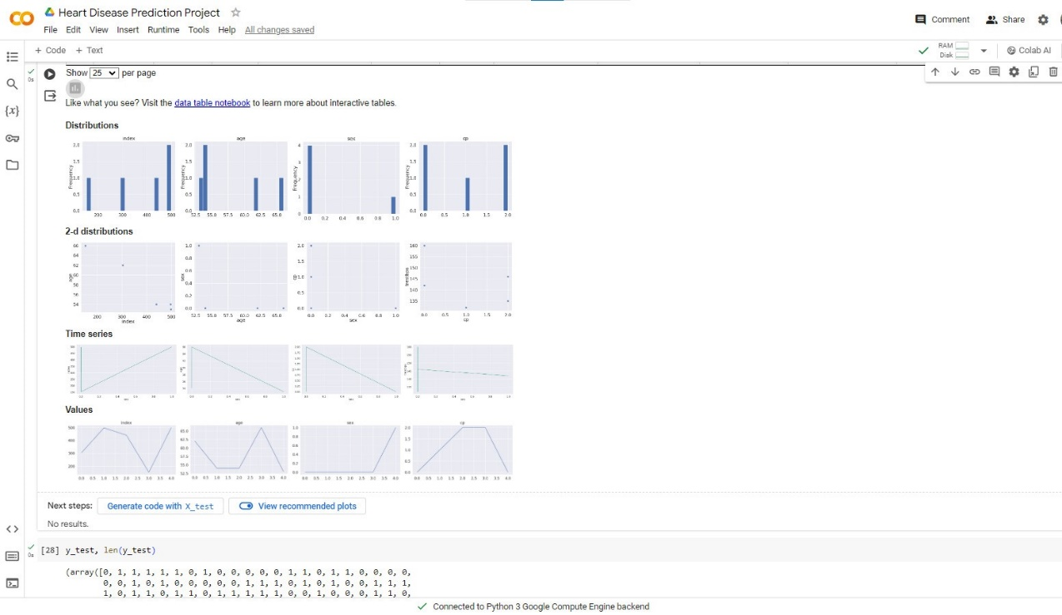

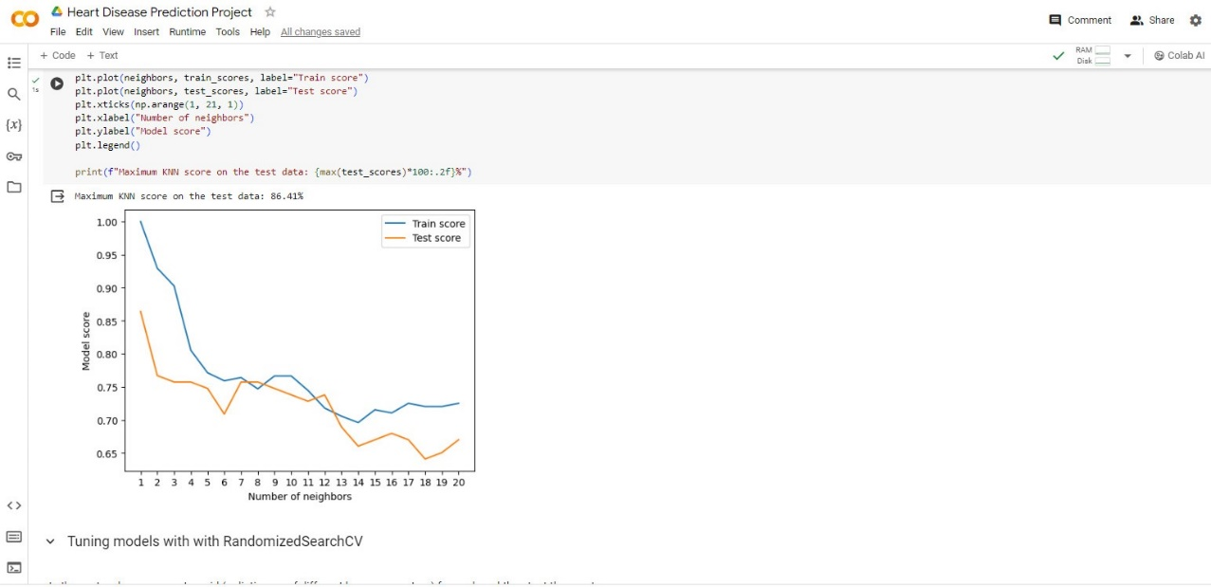

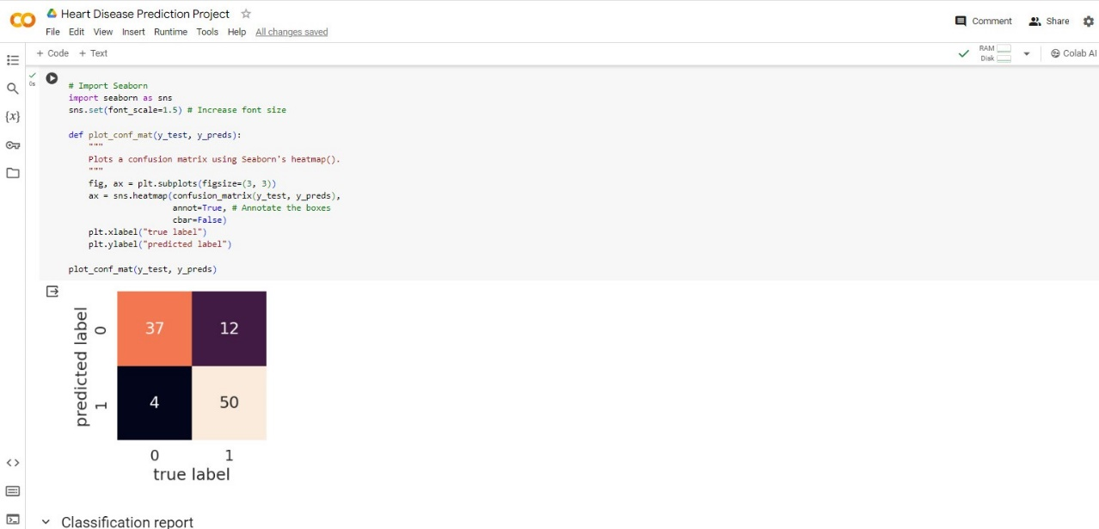

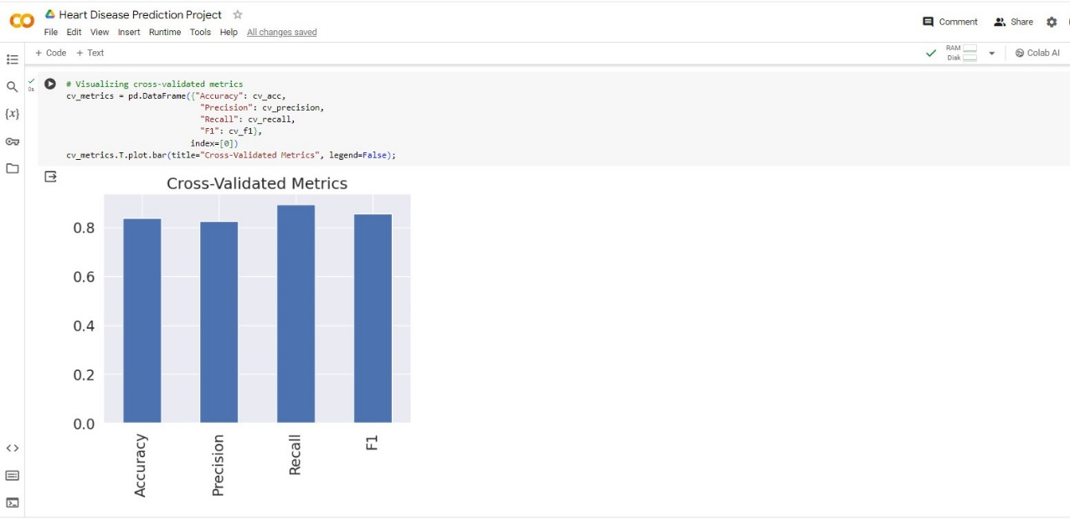

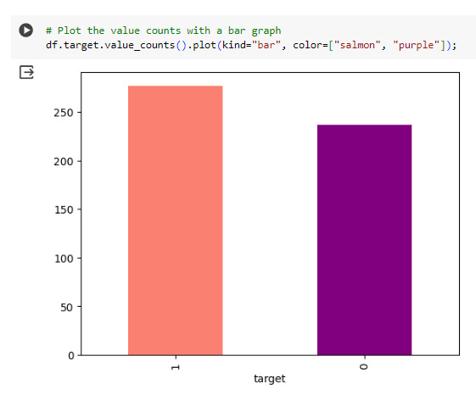

**CONCLUSION**

* In conclusion, the Heart disease prediction system project holds significant promise in enhancing the user experience and driving engagement on the platform. Through the implementation of advanced machine learning algorithms.
* Identifying the processing of raw healthcare data of heart information will be the long term saving of human lives and early detection of abnormalities in heart conditions. Mechine learning techniques were used in the this work to process raw data and provide a new and novel discernment towards heart disease.

**FUTURE SCOPE**

1. **Integration of Multi-omics Data**: Incorporating multi-omics data, including genomics, proteomics, and metabolomics, can enhance the predictive accuracy of heart disease models by capturing underlying biological mechanisms and genetic predispositions.
2. **Deep Learning Models**: Future research could explore the application of deep learning models, such as convolutional neural networks (CNNs) and recurrent neural networks (RNNs), for heart disease prediction. These models can automatically learn hierarchical representations from raw data, potentially uncovering subtle patterns and interactions that traditional machine learning algorithms may overlook.
3. **Longitudinal Data Analysis**: Longitudinal studies tracking individuals over time can provide valuable insights into the progression of heart disease and the dynamic nature of risk factors. Analyzing longitudinal data using advanced statistical methods, such as longitudinal mixed-effects models

**REFERENCES**

**https://colab.research.google.com/github/CongLiu-CN/AIisLove/blob/master/_notebooks/2020-04-30-end-to-end-heart-disease-classification.ipynb#scrollTo=IPcccxtnq-lh**

**CODE**

**NM – PROJECT VIDEO**

**Thank you!**